PUBLIC HEARING NOTICE
Municipal District of Ranchlands No. 66

PROPOSED ROAD CLOSURE

BYLAW NO. 2023-03
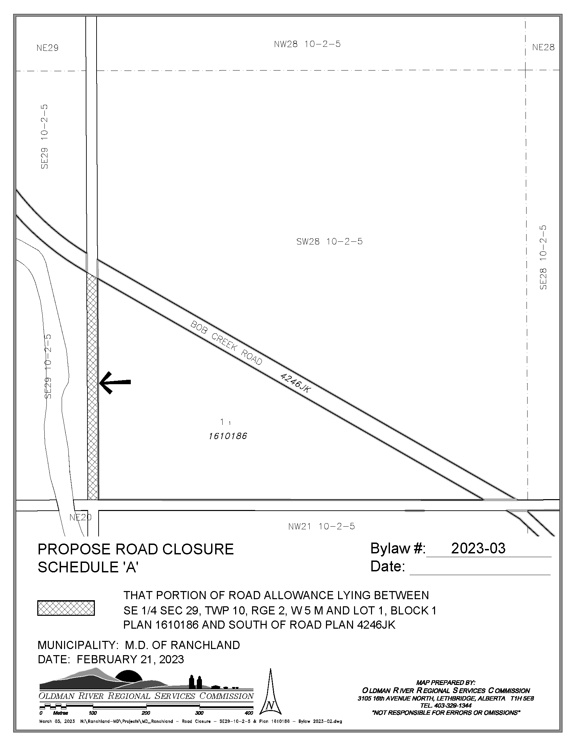
PURSUANT to section 22 of the Municipal Government Act, Revised Statutes of Alberta 2000, Chapter M-26, as amended, notice is hereby given that the Council of the MD of Ranchland will consider a bylaw to close and create a title in the name of the municipality for subsequent sale and consolidation to an adjacent parcel of land for the roadway as illustrated in Schedule A and described as:

THAT PORTION OF ROAD ALLOWANCE LYING BETWEEN SE29-10-2-5 AND LOT 1, BLOCK 1, PLAN 161 0186 AND SOUTH OF ROAD PLAN 4246JK IN THE MUNICIPAL DISTRICT OF RANCHLAND NO. 66 AS SHOWN ON THE ENCLOSED SKETCH.

EXCEPTING THEREOUT ALL MINES AND MINERALS

THE PURPOSE of the bylaw is to close a portion of undeveloped public roadway that is not required for public travel and create separate title to such lands in the name of the municipality for sale and consolidation to an adjacent parcel of land.

THEREFORE, TAKE NOTICE THAT a public hearing to consider the proposed Bylaw No. 2023-03 will be held in the MD of Ranchland No. 66 Council Chambers at 1:00 p.m. on June 6 at Chain Lakes Provincial Park.

AND FURTHER TAKE NOTICE THAT anyone wishing to make a presentation regarding the proposed bylaw should, in writing, notify the MD of Ranchland No. 66 no later than 4:00 p.m., on June 2, 2023. Both written and/or verbal presentations may be made to Council at the public hearing.

AND FURTHER TAKE NOTICE THAT a copy of the proposed bylaw may be reviewed at the MD of Ranchland No. 66 office during normal business hours.

DATED at the MD of Ranchland No. 66 in the province of Alberta this 19 day of April, 2023.

Robert Strauss
Chief Administrative Officer
MD of Ranchland No. 66
Box 1060, Nanton, Alberta T0L 1R0

